Discover and develop skills by personalizing your LinkedIn Learning experience.
The same great content from Lynda.cοm is delivered through an intuitive, new learning experience that’s powered by insights from the LinkedIn network. With LinkedIn Learning, you can discover the skills you need to advance your career with personalized course recommendations based on your experience.

Getting Started

Log into MyCoyote Portal>select My Employment tile  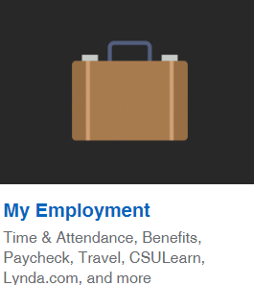 | Select the LinkedIn Learning tile
Connect an existing LinkedIn profile visit ITS Support Knowledge Base Articles.
It is not required to connect your profile from your existing LinkedIn account to use LinkedIn Learning at CSUSB. | 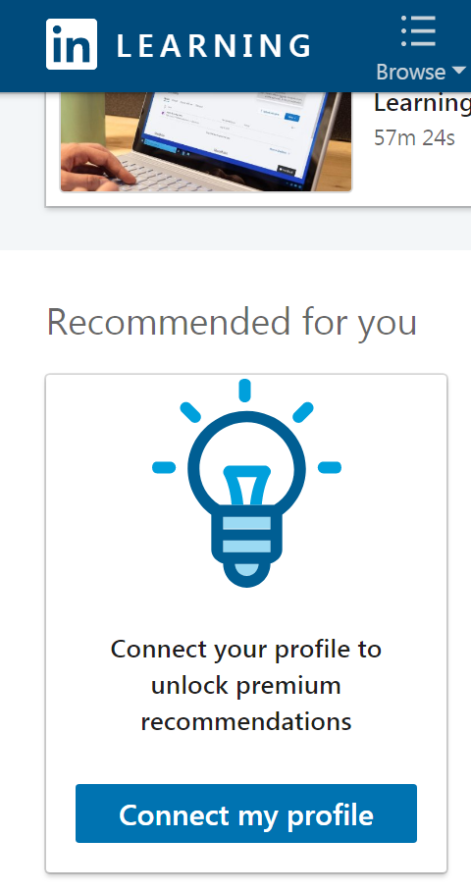

LinkedIn Learning Main Menu
Personalize your LinkedIn Learning experience by selecting skills you are interested in. Make your selections as they apply to your skillset and interests.  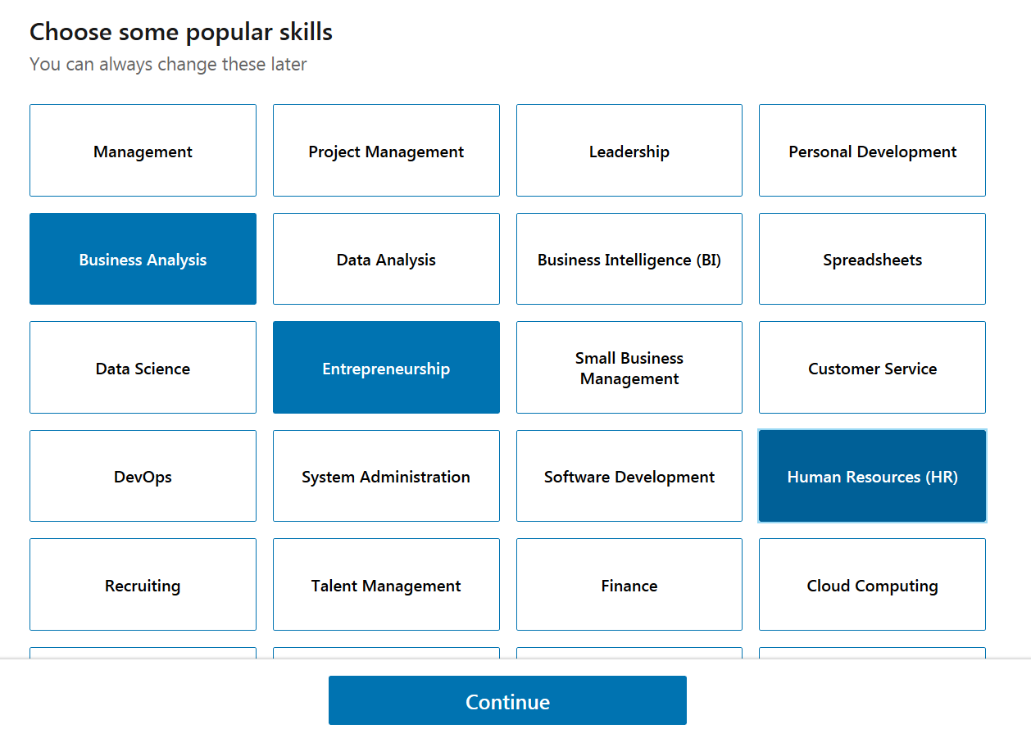 | Take a Tour to become familiar with the new and improved learning experience brought to us by LinkedIn Learning.  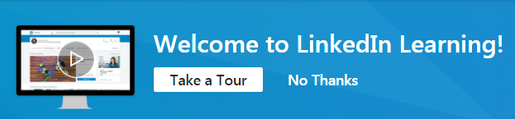

- Browse
Browsing in LinkedIn Learning has been made easy. You can browse for content under the business, creative, and technology sections based on subjects, software, and learning paths. You can also browse based on tags, skills, and custom content.

Move your cursor over one of the following sections:
Business
Creative
Technology

- In Progress

Select “In Progress” to view the courses you are currently viewing.
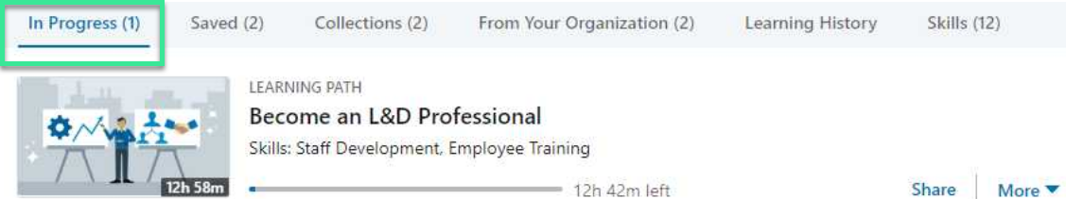

- Saved

You can save courses or videos you're interested in by clicking the Save icon.
The Save icon can be found below any course recommended on your
LinkedIn Learning homepage, to the right of a course title in your LinkedIn Learning search results list, or above the video on any course page.

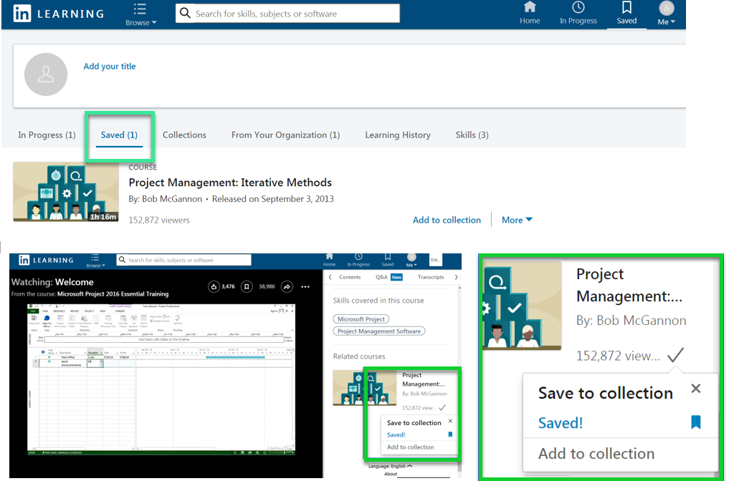

- Me
Using Me provides a quick navigation option to features in LinkedIn Learning. Personalized course recommendations, suggests the most relevant courses or videos for you based on skills known to be important to a given job function or role. Sign out using Me menu option.
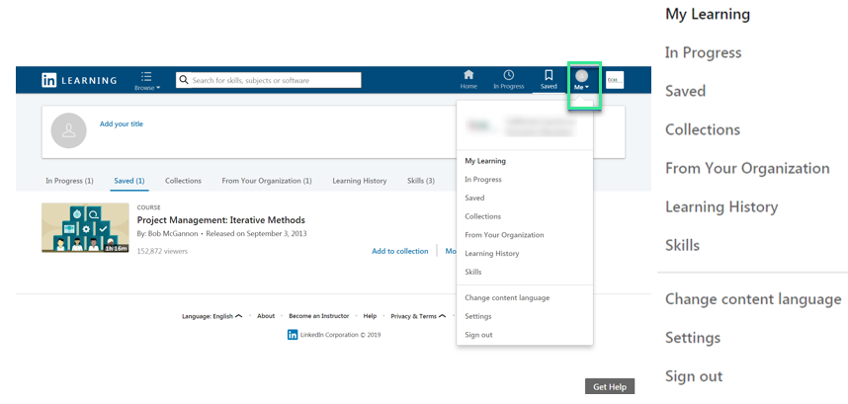

Helpful to know…..

View learning topics From Your Organization
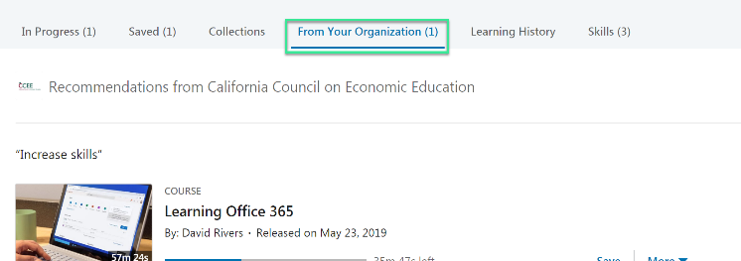
On the default home page links are displayed for In Progress, Saved, Collections,
From Your Organization, Learning History and Skills.

Taking Notes - As a learner, you can make personalized notes while you watch a Learning video.

Adding notes is an efficient way to:
- Add context to what you are learning.
- Remind yourself of the sections within a video that are the most relevant to your needs.
Each note is also timestamped to the place in the video where the note was added, allowing you to quickly jump back into your learning.
Important: The ability to add notes is not available within the Learning apps. To access the notebook feature, please use a desktop device
To add a note:
- In Learning, navigate to the course you wish to view.
- On the right rail, click on the Notebook tab.
- As the video plays, add notes in the box.
- Select Enter on your keyboard to save the note to your notebook.
- Your notes will appear in chronological order.
Select the arrow to navigate to the Notebook link.
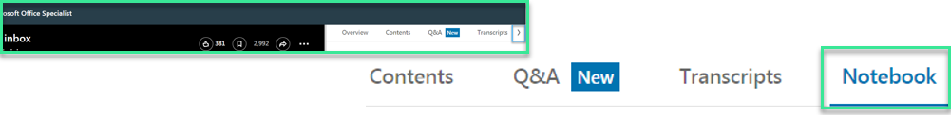
To view an existing note:
- In LinkedIn Learning, navigate to the course you wish to view.
- On the right, click on the Notebook tab.
- Your notes will appear in chronological order .
To edit or delete a note:
- In LinkedIn Learning, navigate to the course you wish to view.
- Select the Notebook tab.
- Type your notes in the box, locate the note you wish to edit or delete.
- Select Edit to update your existing note, or Delete to remove the note from your list.

FAQs

- Is the content the same on LinkedIn Learning as on Lynda.com?
Yes, all of the same great content you know from Lynda.com will be on LinkedIn Learning.
The content you know and love just got better.

- More relevant recommendations
A personalized learning experience powered by the LinkedIn network, based on trending skills in your field.

- Can I bring across my history from Lynda.com? Or will I have two separate accounts for Lynda.com and LinkedIn Learning?
Yes, when the upgrade is complete all of your history, in progress and bookmarks will be in your new LinkedIn Learning account. And no, you will not have two separate accounts.
All the same access to your learning history, account info, and certifications.
For assistance with technical issues contact the Technology Support Center at (909) 537-7677 or support@csusb.edu .

